Dasha Gore

DAD 220

Professor Whitaker

September 3, 2022

Module One Lab

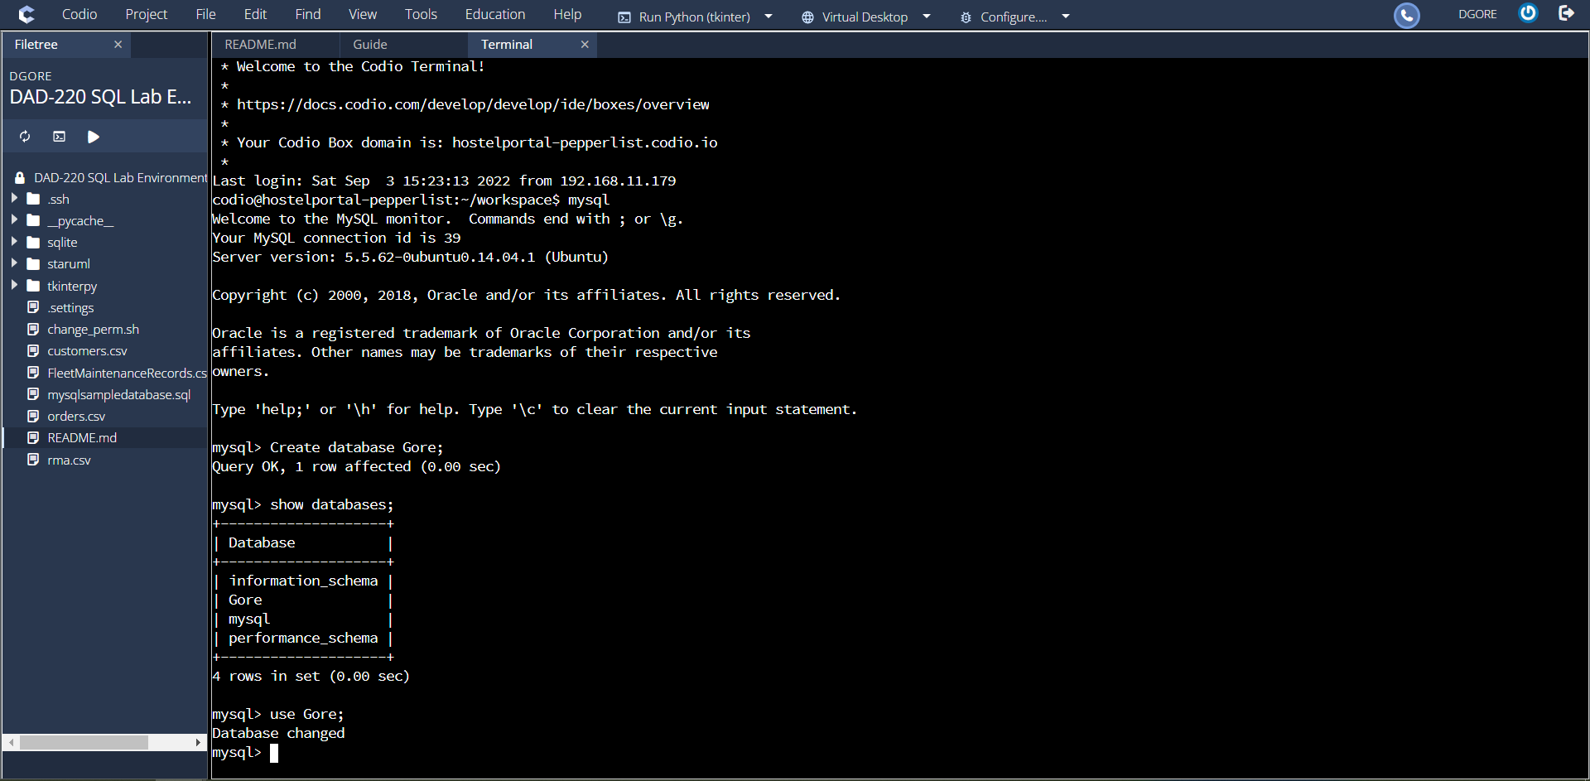

1. **Create a new database**and update the name to your last name, then connect to it. Type the following commands after the prompt mysql>:
   1. create database last_name_here;
      1. For example, if your database is going to be named Jetson, then substitute Jetson for “last_name_here.”
      2. Press **Enter**.
   2. show databases;
      1. Press **Enter**.
      2. You should see a listing of all of the databases (or schemas) in MySQL, including the one you just created.
   3. use last_name_here;
      1. Press **Enter**.
      2. Substitute the name of your database (for example, Jetson) for “last_name_here”. This SQL statement connects your MySQL session to the database you’ve just created.
      3. Capture a screenshot or clipping of the results of this action, and place it in a Word document for submission.

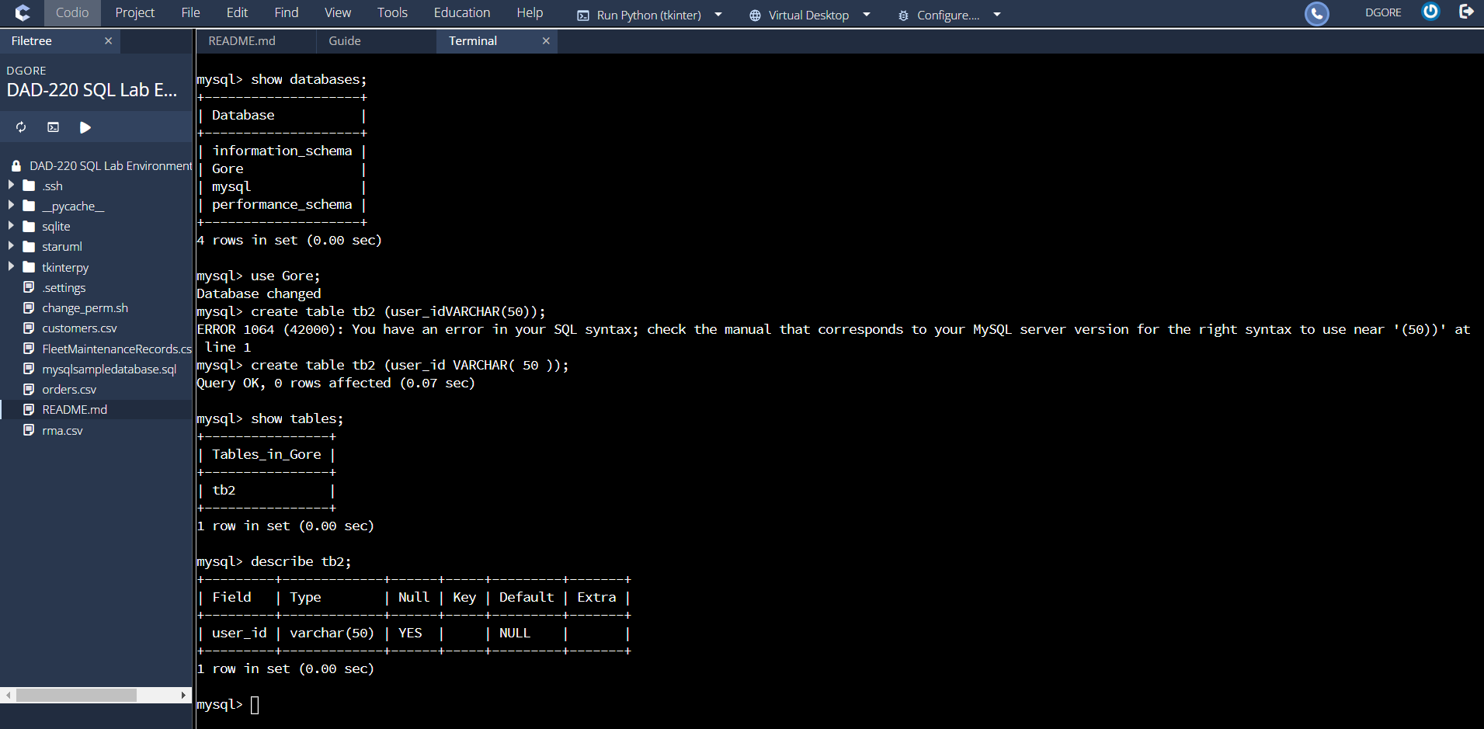

1. **Create a table** called **tb2** and list out the tables in your database with one field by typing the following commands after the prompt mysql>:
   1. create table tb2 (user_id VARCHAR( 50 ));
      1. Press **Enter**.
   2. show tables;
      1. Press **Enter**.
   3. describe tb2;
      1. Press **Enter**.
      2. Capture a screenshot or clipping of the results of this action, and place it in a Word document for submission.

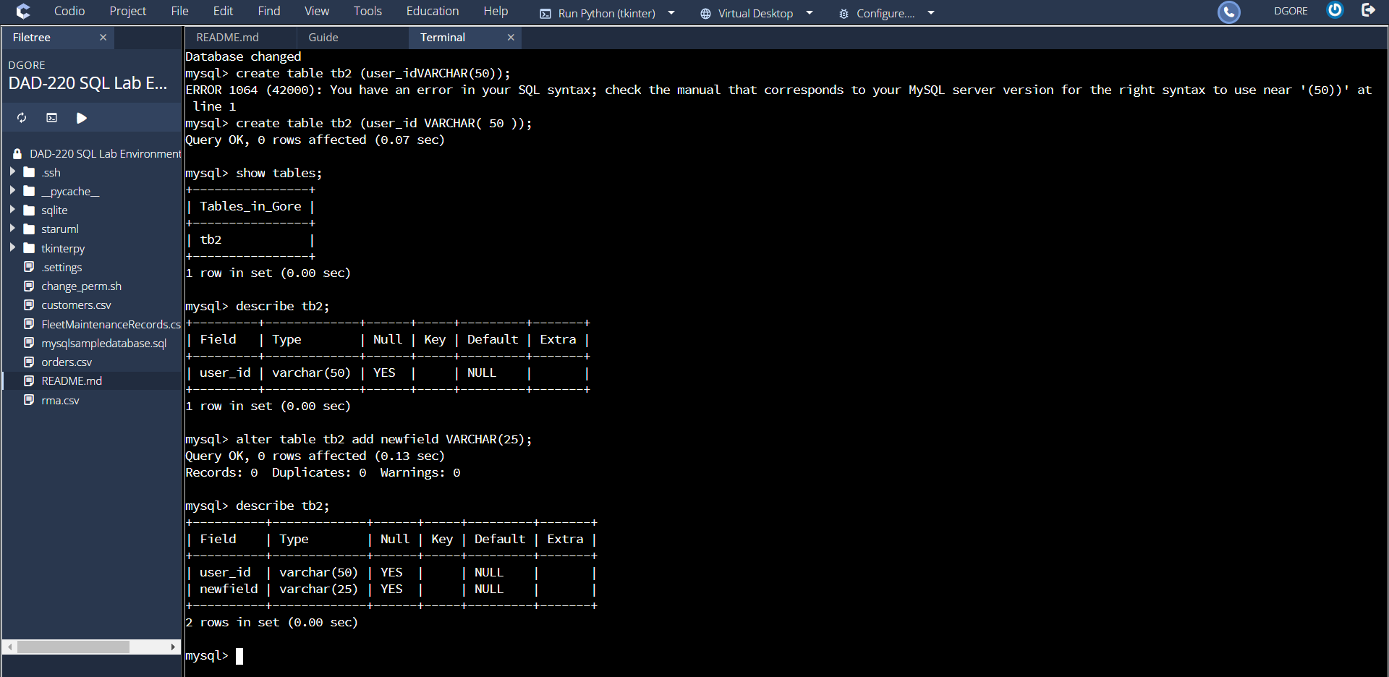

1. **Add a second field into the table and describe it.** Do this by entering the following commands after mysql>:
   1. alter table tb2 add newfield VARCHAR(25);
      1. Press **Enter**.
   2. describe tb2;
      1. Press **Enter**.
      2. Capture a screenshot or clipping of the results of this action, and place it in a Word document for submission.